QUALIFYING EXPERIENCE REPORT:
“Determining Place Regulations on the Internet:
Burning the Global Village to Roast the Pig”

Southern States Communication Association
77th Annual National Conference
Louisville, Kentucky, March 29 2007

Tami Sutcliffe

SLIS INFO 6950

Dr. Brian O’Connor

April 16 2007
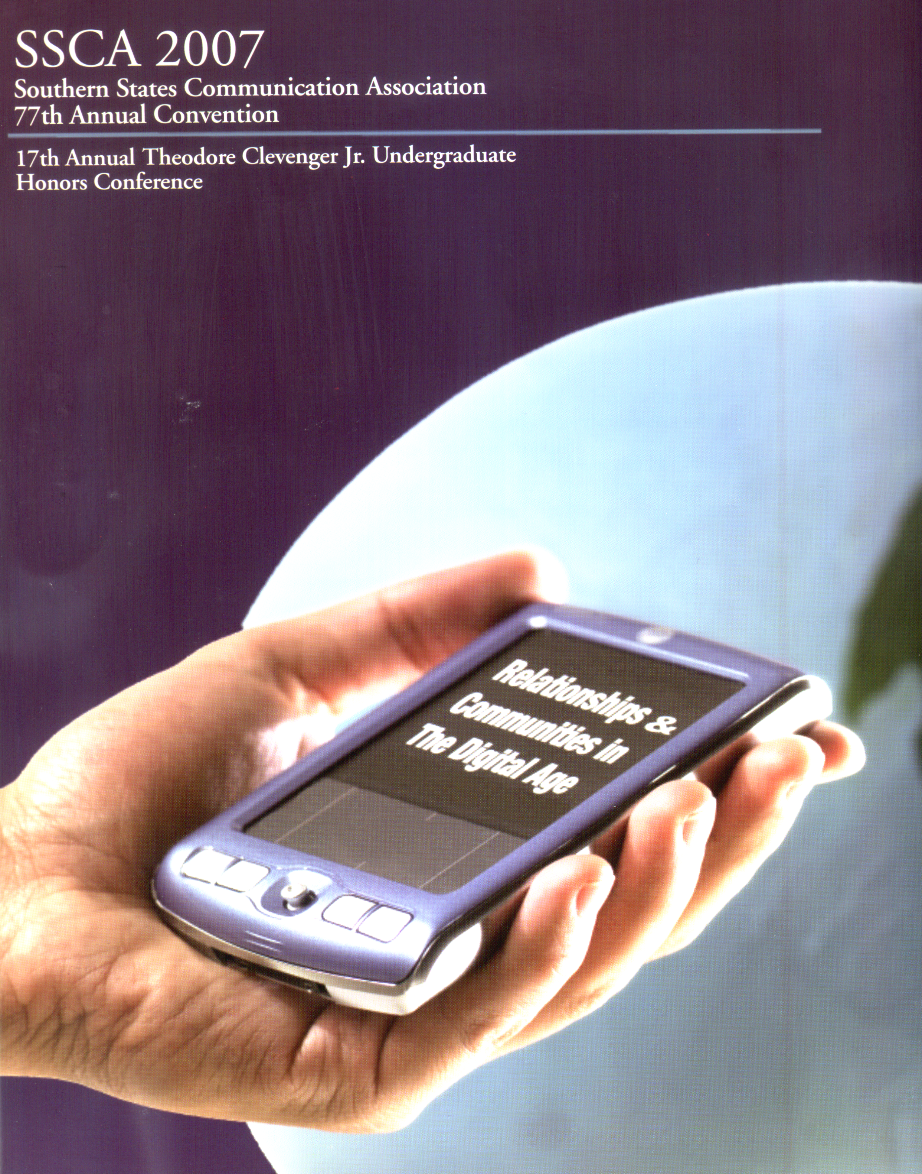
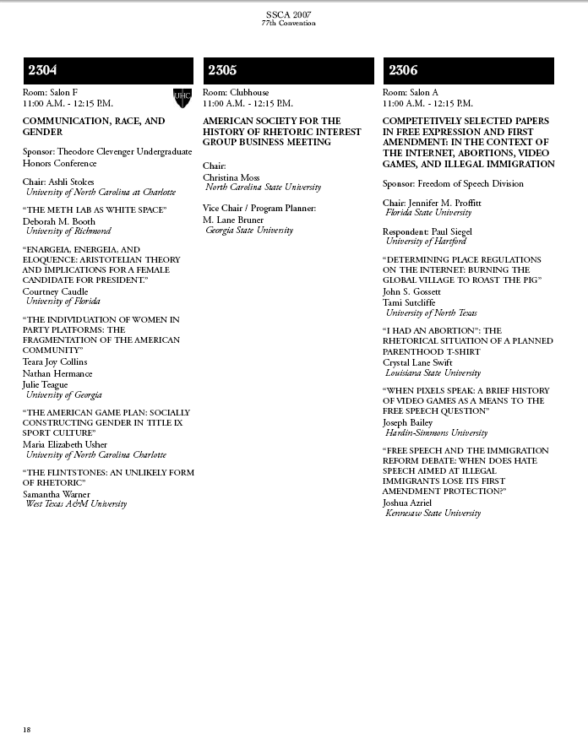

Determining Place Regulations on the Internet:
Burning the Global Village to Roast the Pig
John S. Gossett and Tami Sutcliffe
University of North Texas

Southern States Communication Association
77th Annual National Conference
Louisville, Kentucky, March 29 2007

Presented with “Competitively Selected Papers In Free Expression And First Amendment:
In The Context Of The Internet, Abortions, Video Games, And Illegal Immigration”

Sponsored by the Freedom Of Speech Division
Chair: Jennifer M. Proffit, Florida State University
Respondent: Paul Siegel, University of Hartford

Project is available online at http://www.informationart.org/symbolic.html

In Spring 2006, I enrolled in Dr. John S. Gossett’s Freedom of Expression seminar (COMM5540), part of the approved curriculum in the UNT Interdisciplinary Information Science Doctoral Program. This course is designed to highlight legal issues in communication through the study of the theories, statutes, and cases involving the First Amendment guarantee of freedom of speech.
I was the lone information scientist in an energetic group of communication specialists. Being surrounded by students who were highly focused in completely divergent fields sparked some lively discussion. My interest in free speech law, particularly censorship issues, grew as I researched how these laws were affecting Internet use in traditional libraries and the online community as a whole. The other students expressed interest in my findings: most of us had no previous contact with the politicized “radical, militant librarian” aspects of information science.
During the seminar I worked on several projects which centered on time, place and manner regulations as applied to the online environment. I began researching current laws related to Internet use and libraries, and became intrigued by the evolving Supreme Court rulings related to these issues.
As we completed the course, Dr. Gossett asked me if I would be interested in working with him on a paper related to online free speech regulations to be presented at the 2007 Southern States Communication Association’s annual convention in Louisville, Kentucky. I agreed to this project and enrolled in a Special Projects course (COMM5900) during the Summer 2006 semester for this purpose.
Over the course of the summer I completed extensive background reading on free speech issues online, prepared several drafts and accumulated research materials on this topic. I submitted a draft titled “Determining Place Regulations on the Internet: Burning the Global Village to Roast the Pig “ to Dr. Gossett on September 1, 2006 . He edited and reformatted our materials before submitting our proposal prior to the September 26, 2006 deadline.
In January of 2007 we were notified that we were one of the “Competitively Selected Papers In Free Expression And First Amendment: In The Context Of The Internet, Abortions, Video Games, And Illegal Immigration” sponsored by the Freedom Of Speech Division at the SSCA conference. We were scheduled to present our paper on March 29, 2007.
Due to serious health concerns, Dr. Gossett was unable to attend the conference. He suggested I present our work on my own and I made arrangements to do this. The division chair (Jennifer M. Proffit of Florida State University) and the respondent (Paul Siegel of the University of Hartford) approved these arrangements and I flew to Louisville on March 28 to begin this process.

SSCA Background
The Southern States Communication Association [SSCA] was established in 1930 to “promote the study, criticism, research, teaching, and application of the artistic, humanistic, and scientific principles of communication.” The SSCA is a not-for-profit organization which publishes The Southern Communication Journal quarterly. The majority of members are university teachers and students involved in a broad spectrum of communications fields.
The SSCA annual convention is designed “for members to share ideas, observations, and experiences about studying, teaching, and performing.” The 2007 convention was held March 28th - April 1st in Louisville, Kentucky in the Louisville Downtown Marriott hotel, about ten minutes from the Louisville airport.
The theme of the 2007 conference was “Relationships and Communities in the Digital Age.” The focus during the week was on the stated idea that “personal relationships, universities, politics, leisure activities and professional associations are being transformed by new communication technologies.” This theme successfully skewed what might have been a debate/performance-intensive group of activities more closely toward my more admittedly geeky interests and I discovered that “communication” turned out to be a very wide and inclusive subject area.

At the Conference
I arrived in the early afternoon of the first day of the conference. The schedule for the first day consisted mainly of registration, organizational meetings and an orientation for new members. I had joined SSCA in January when our project was accepted for presentation, and had pre-registered online for the full conference. I spent the rest of the day reviewing the new member information, checking on the facilities for my presentation and meeting other new SSCA members.
I was scheduled to present at 11m on the second day of the conference, March 29 in Salon A. One lesson I learned in this experience was that staying at the hotel where the gatherings take place is a relaxing way to save an enormous amount of time. Other student presenters I met had opted to stay at hotels a few blocks away from the conference site, and although downtown Louisville is small and very accessible, it was enormously convenient to stay in the facility where the meetings took place instead of hiking several blocks in the wind and humidity the morning of your event. I had time the evening before to make sure I knew where my meeting was being held, and even had a chance to look inside to see what the room was like.
On March 29 I attended a session titled “Mediated Gender Images” at 9:30 am, which was an intriguing report from researchers looking at various configurations of media directed at women. Webber and Crumley from Southern Adventist University led an especially interesting discussion about their research into magazines targeted at young women (ages 13-18). My masters thesis was related to gender and communication online, so I was particularly interested in the ideas this group detailed.
At 10:45 I joined the other members of my panel to set up our presentations. A second critical lesson I learned from this experience was to (a) always carry your own presentation hardware and (b) always have a backup of your data source. During registration/check in, I had double-checked with the hotel staff, to make sure there would be a computer and projector set up in our meeting room on the following day. The staff at check in assured me that there would be equipment set up before our scheduled event. However, when we arrived in our room fifteen minutes prior to the start time, there was no projector. Another presenter had a laptop with her, and my data was in my pocket (on two individual flash drives). The division chair phoned the hotel staff who quickly installed the missing projector, we all downloaded our files to the volunteer laptop and the session began.
Dr. Jennifer M. Proffit of Florida State University was the chair of the Free Speech Division sponsoring this group. She elected to have everyone complete their presentations and only take questions after everyone was finished.. She asked that we present our projects in the order in which they had been accepted and I happened to be lucky enough to go first. This was a massive relief, as I could then enjoy the rest of the panel presentations in peace.
The last-minute equipment projector installation did not include Internet access, (surprise!) so although my full presentation was online, along with full text of our project (http://www.informationart.org/symbolic.html ) I could not access it in real-time. This was not a crisis, as I had also brought my files on my flash drive. I opened the PowerPoint files quickly and was able to (fairly smoothly) complete my ten minute slide show. (Several people in the audience asked me later for the URL of the project and I had to scribble it down on my business cards. Another lesson I learned from this experience was to have a few printouts with basic URL data in hard copy, just in case there is no Web access during the event. I would have liked to get feedback from as many people as possible but I know it was a hassle for some to access my URL this way. Printed handouts with the URL would have been ideal) In any case, I completed my section without apparent mishap and leaned back with a sigh of relief.
There were three other people presenting in my group:
- Crystal Lane Swift from Louisiana State University read her paper “I Had An Abortion”: The Rhetorical Situation Of A Planned Parenthood T-Shirt”
- Joseph Bailey from Hardin-Simmons University led discussion about his paper “When Pixels Speak: A Brief History Of Video Games As A Means To The Free Speech Question”
- Joshua Azriel from Kennesaw State University talked about his project, “Free Speech And The Immigration Reform Debate: When Does Hate Speech Aimed At Illegal Immigrants Lose Its First Amendment Protection?”
All three speakers had distinct styles and subject matter. One disadvantage to presenting at a conference for communication specialists is that they tend to be very polished public speakers, even at a student level. I felt inordinately geeky at this point, but I was pleased to discover my animated slides were the nicest (despite my voice being the shakiest.)
There were quite a few questions after all four presentations were complete. A person asked me about public library filtering and I wish I could have linked live to the sites in our project to demonstrate some of the problems found in this software. However, I did exchange email addresses with this person later, so perhaps the inability to completely answer a question during a conference is not always bad if it leads to further, more detailed correspondence. Several people asked me some fairly advanced free speech history questions, which the respondent Dr. Paul Siegel handled. I was glad he was a specialist in this area, and frankly was surprised at how extensive his knowledge of some arcane library censorship minutia turned out to be.
After the question and answer period, Dr. Siegel gave each of us a hard copy of his responses to our papers and led a brief discussion on this feedback. [Copy of response paper follows.] Our session led up to several lunchtime meetings, and we finally broke a few minutes after our allotted time.
After lunch, I attended two sessions: “Communication and Popular Culture” which included a discussion examining game content and “Shifting Identities in the Digital Age: Implications of Technological Expansion on Inter- and Intrapersonal Communication.” The last session of the day was “Communication, Media and Technology” which focused on media portrayals of various cultural aspects of communication.
The two sessions I missed which I now wish I had attended were (1) “A Potpourri of Papers on Lying, Arguing, Cheating and Discussing” which listed “A Closer Look at Deception” as a central point of discussion and (2) “Strange Bedfellows: Navigating An Arranged Marriage Between Communication and Informatics” which detailed the formation of a new “College of Information” at the University of Kentucky and the drama/adventure involved in successfully launching this new program.
Overall, this conference was valuable to me because I learned some practical lessons about the logistics of speaking in a strange place, I met and established correspondence with students from other doctoral programs who have interesting dissertation projects underway and I had the world’s best chef salad at a delicatessen on 4th Street in Louisville.

Lessons Learned form this experience:
- Stay in the hotel where your conference is taking place, if possible.
- Carry your own presentation hardware. Do not rely on hotel staff to provide.
- Have multiple backups in various formats of your data source.
- Assume you will NOT have live Internet access. Prepare accordingly.
- Make hardcopy handouts available, if you use URLs in your data
- Bring business cards
- Wear something with a pocket to comfortably collect cards from others.
- Attend as many other sessions as possible.
- Stay and talk to other students after their presentations. They are relieved it is over, too, and sometimes have surprising insight in your field of interest.
- Explore small restaurants which are busy at lunchtime.

Access to files for this project:

Project web site:
http://www.informationart.org/symbolic.html

Project PowerPoint file:
http://www.informationart.org/place.ppt

Full text of project paper [Word]:
http://www.informationart.org/GossettSutcliffe.doc

Full text of project paper [PDF]
http://www.informationart.org/GossettSutcliffe.pdf

Full text of project paper [HTML]
http://www.informationart.org/placeregulations1.html

Scribd file:
http://www.scribd.com/doc/11606/Place-Regulations-on-the-Internet-SutcliffeGossett-SSCA-2007

Respondent’s Comments
Competitively Selected Papers in Free Expression and the First Amendment
Southern States Communication Association
Louisville, KY: March, 2007

Paul Siegel
University of Hartford

•Determining Place Regulations on the Internet: Burning the Global Village to Roast the Pig, by John S. Gossett and Tami Sutcliffe of the University of Texas

The paper does a fine job of explicating the history and philosophy undergirding traditional public forum doctrine. They also provide a real service to this reviewer by introducing him, however briefly, to the work of David Weinberg.
There seems to be some cognitive slippage in the category scheme that follows, however. I am not sure, for example, if the “history of U.S. online speech regulation, and the whole issue of pornography regulation online fits under the description of “Type I place restrictions,” defined as place restrictions enforced by a governmental agency which limit the way an individual may use the Internet in a public setting. I suppose that only the public library case really fits in here.
The Type II restrictions, in which public schools go after their students’ off-campus use of the Internet, are especially troubling. Although there are not many well-publicized instances of this phenomenon, I wish this section of the paper had been expanded a bit.
The Type III restrictions seem to be a primarily non-American phenomenon, thus by definition beyond the scope of the First Amendment.
I will admit too I was not sure how the discussion of how one defines speech v. non-speech elements of an act has relevance to the concept of “space,” which is supposed to be the focus of this essay.
I would suggest, as the authors revise for possible publication, they consider what aspects of online communication are illuminated most by the concept of space. If everything about the Internet is a space-related discussion, it seems we prove, or bite off, too much. But surely there are some things about cyberlaw that are more intuitively space-relevant than others. Certainly the notion of jurisdiction online is one such category, and the authors show an awareness of this fact early on. But there are others. Deep linking, through which an unsuspecting web surfer is taken to a different web site without prior notice, seems a clear instance of a space-relevant behavior.

The authors likely would need to update this section by pointing out that the Children Online Protection Act was declared unconstitutional in March, 2007. See ACLU v. Gonzales, 2007 U.S. Dist LEXIS 200008 (E. D. Pa. 2007).
U.S. v. American Library Association, 539 U.S. 194 (2003).

